+53g

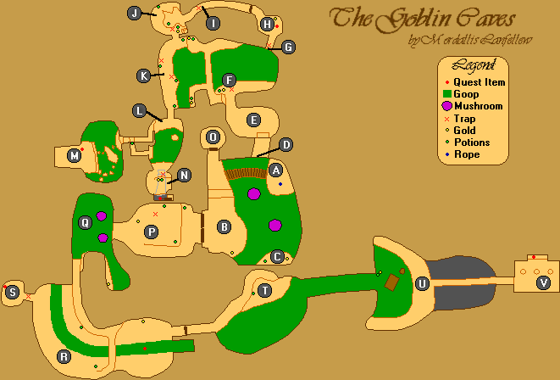



Teleporter Skip

Ogre +300g

**Gerrick**:

* Buy Items
  + Shovel 30g
  + Aloe 15g
  + Compass 50g
  + Feather x10 100g
* Iszara
* League Pirates
* Knows More
* Smuggler’s Den

(↖) Town -> Devil’s Den

Boneman 3g

N’Gasta’s Amulet **(SPLIT)**

(←) Devil’s Den -> Ogre Mountains

Glass Bottle

(→) Ogre Mountains -> Town

**Avik**: (1g)

* Music
* Yokudan Lad

Eyepiece

**Palace Guard**:

* See Richton
  + Deliver Amulet **(SPLIT)**

**Prisoner:**

* Escape
* Find League
* Lighthouse

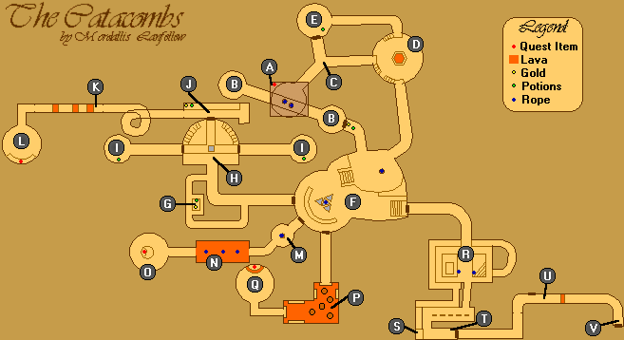



Strength and Torch

Rune Door Skip

Escape **(SPLIT)**

**Prnell**:

* Iszara
* Eyepiece

**Krisandra**:

* Smuggler’s Den
* Lakene

Locket

**Lakene**:

* Locket

**J’ffer**:

* Buy Books
  + Dwarven Lore (54g)

**Lakene**:

* Gambling at Den
* Give Me Password
* Give Locket

**Urik**:

* Iszara
* Malachite
* League Insignia
  + You Were Iszara’s Friend
    - She Would Have Liked You

League Insignia **(SPLIT)**

Health

(↙) Town -> Ruins

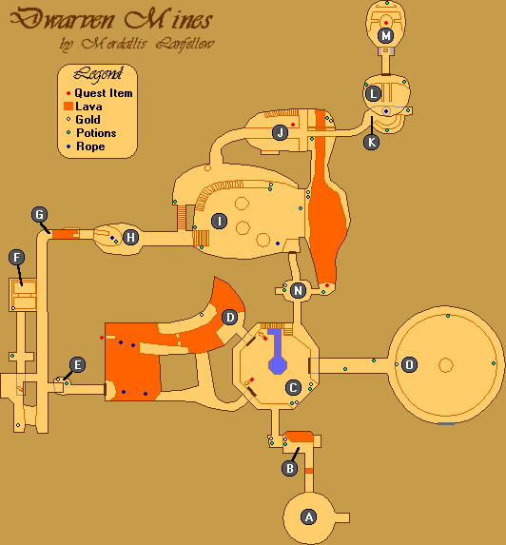



Scarab Door Skip

(→) Ruins -> Saintsport

Observatory

Light fire, flash flash flaaaash

Fast lighthouse strat

League Hideout **(SPLIT)**

Use Strength

**Basil**:

* Iszara
* Iszara’s Messenger Boy
* Part of You

(↑) Saintsport -> Town

**Nidal**:

* Temple
* Brother Kithral
* Kithral’s Journal

**Mariah**

**Falicia**:

* Soulgem

**Joto**:

* Joto
* Magic
* Please
* Iszara

Old Quarter **(SPLIT)**

Health

(↓) Town -> Saintsport

Flask of Lillandril **(SPLIT)**

(↖) Saintsport -> Ogre Mountains

(↖) Ogre Mountains -> Devil’s Den

Boatman (3g)

Orc’s Blood + Amber

Hist Sap + Unicorn’s Horn

Ectoplasm + Deadra Heart

**Clavicus Vile**:

* Daedra
* Why Are You Doing This?
  + Give Flask for Sister’s Soul
  + What Do You Want?
    - Wager My Soul Against Sister's Soul
      * …

Iszara’s Soul **(SPLIT)**

(↑) Saintsport -> Town

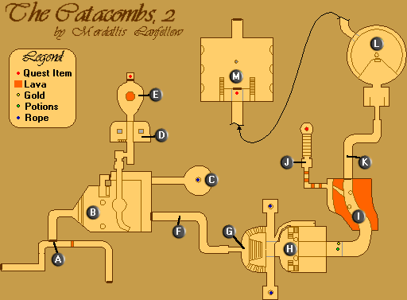



-*******

--******

---*****

**-*****

**---***

**-*--**

**-**-**

*--**-**

**Coyle**:

* Hayle
* Is Your Mother All Right?
* Soul Snare
* Serpent
* Serpent’s Path
* Yes

**Saban**:

* Help with Soulgem

Palace Courtyard **(SPLIT)**

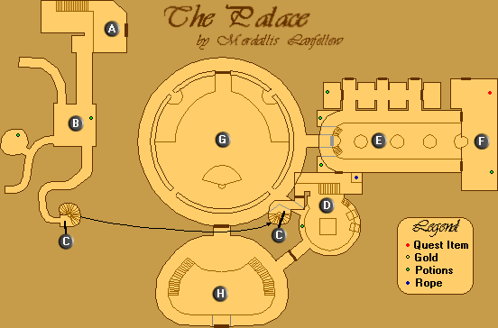

Richton **(SPLIT)**